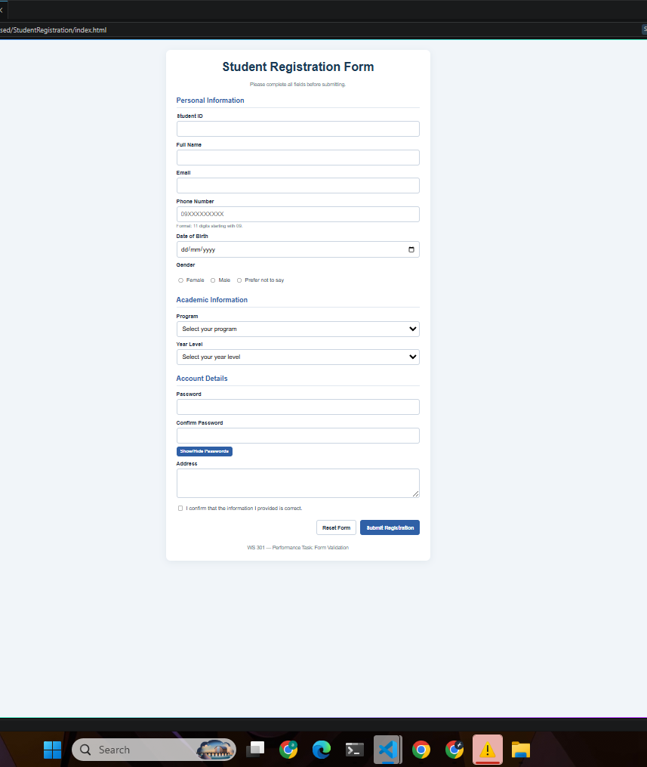
Initial Form – before entering information.
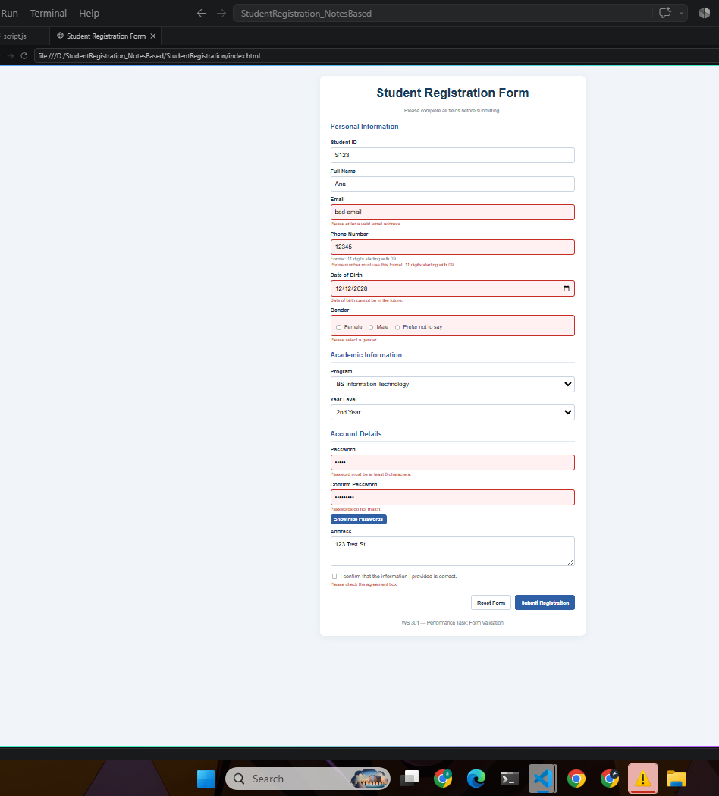
Validation Errors – showing incorrect or incomplete information.
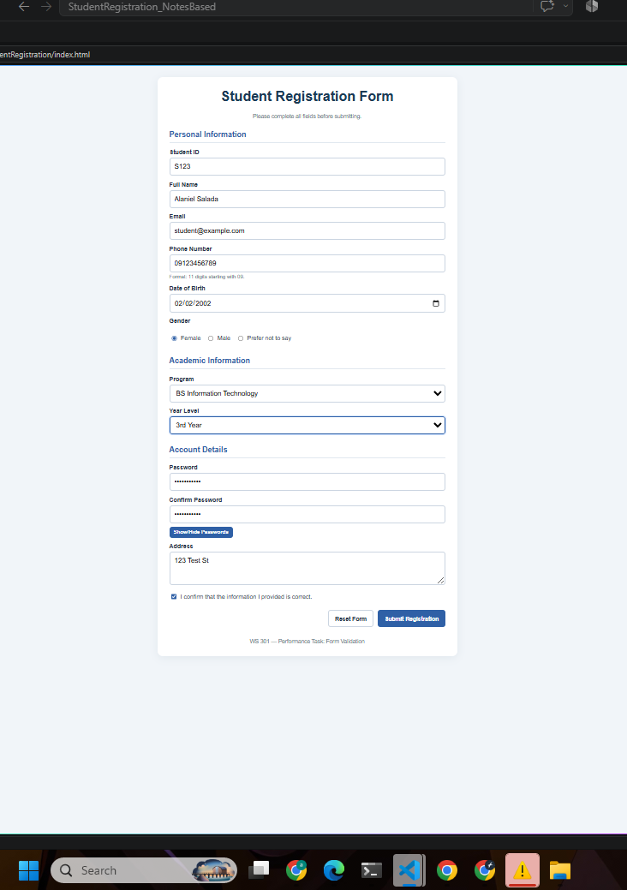
Corrected Form – showing errors being corrected.
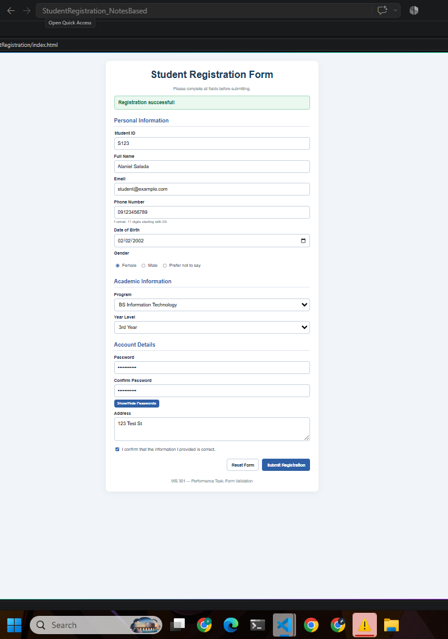
· Successful Form – showing the success message.
3. Short Explanation (add these to the explanations to the docx file together with your screenshots.)

This form collects student registration details and checks them before submission. It trims extra spaces, validates the email format, phone number format, program and year selection, gender choice, password match, and agreement checkbox. I used addEventListener("submit", function(event) { ... }) with preventDefault() so the page does not reload or submit when information is invalid. Each invalid field shows a specific error message in a separate span, and the form highlights incorrect inputs by adding the .error class and removing it when corrected. I also styled the gender error area with an additional CSS class called .error-group to show group-level validation. The form uses custom data-* attributes such as data-error and data-phone-format, and JavaScript reads them with element.dataset to create clearer validation messages. For the password toggle feature, I changed the input type attribute from password to text using setAttribute(), which makes the form more user-friendly and functional.

